In this program has 6 formulas for transforming a picture.

* RGB to YIQ
* YIQ to RGB
* RGB to YCBCR
* YCBCBR to RGB
* YIQ to YCBCR
* YCBCR to YIQ

The transform formula is bellowing.

**RGB to YIQ**

    y = (0.299)*r + (0.587)*g + (0.114)*b

    i = (0.596)*r - (0.274)*g - (0.322)*b

    q = (0.211)*r - (0.523)*g + (0.312)*b

**YIQ to RGB**

    r = y + (0.956)*i + (0.620)*q

    g = y - (0.272)*i - (0.647)*q

    b = y - (1.108)*i + (1.705)*q

**RGB to YCBCR**

    yy = (0.257)*r + (0.504)*g + (0.098)*b + 16

    cb = -(0.148)*r - (0.291)*g +(0.439)*b + 128

    cr = (0.439)*r -(0.368)*g - (0.071)*b + 128

**YCBCBR to RGB**

 r = (1.164)*(yy-16) + (1.596)*(cr-128)

    g = (1.164)*(yy-16) - (0.392)*(cb-128) - (0.813)*(cr-128)

    b = (1.164)*(yy-16) + (2.017)*(cb-128)

**YIQ to YCBCR**

Using above formula **YIQ to RGB** than **RGB to YCBCR**

**YCBCR to YIQ**

Using above formula **YCBCR to RGB** than **RGB to YIQ**

IN this program you can choose the mode that you want to transform.

* **DEMO1(RGB to YIQ)**

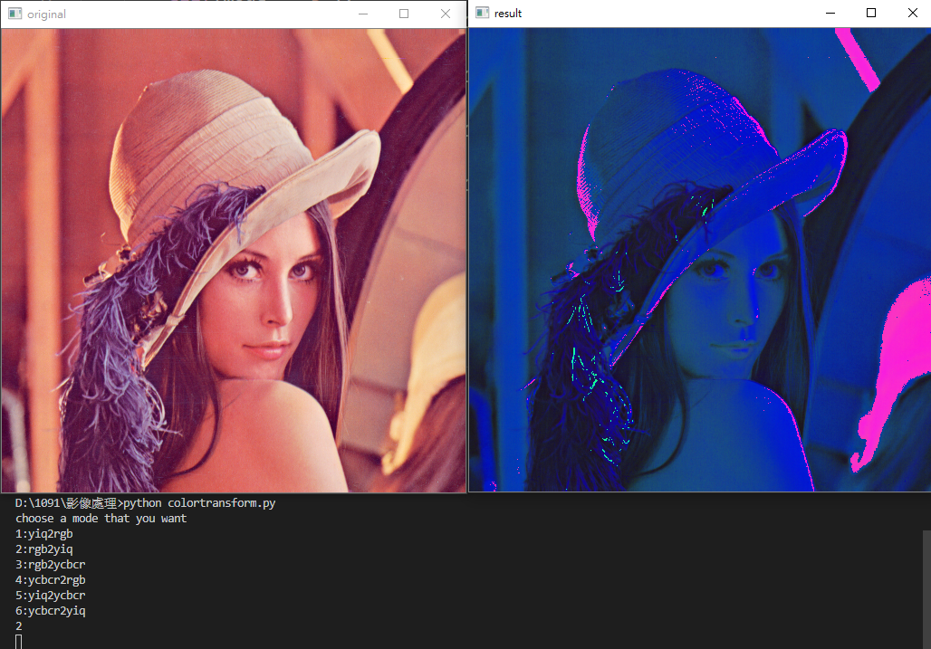

* **DEMO2(RGB to YCBCR)**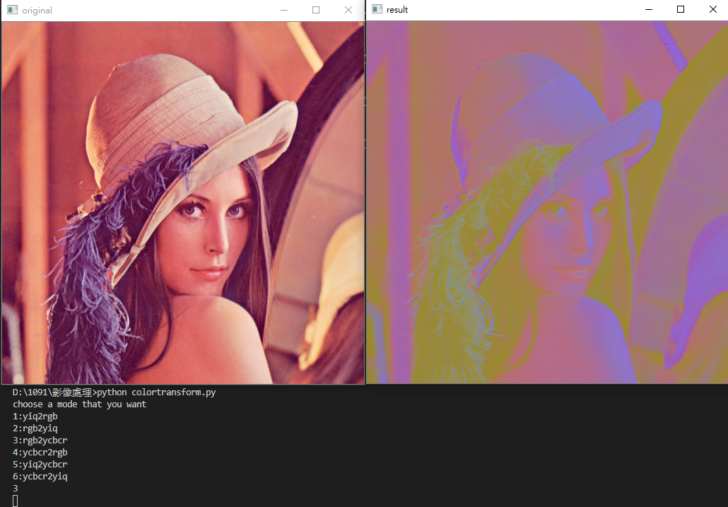
* **DEMO3(RGB to YIQ)**

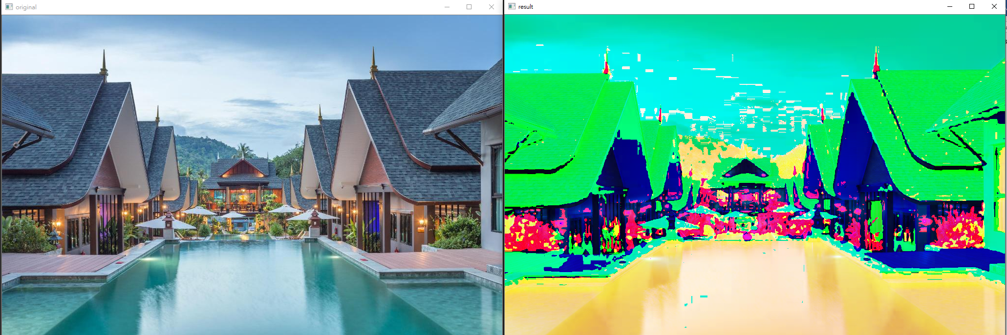

* **DEMO3(RGB to YCBCR)**

